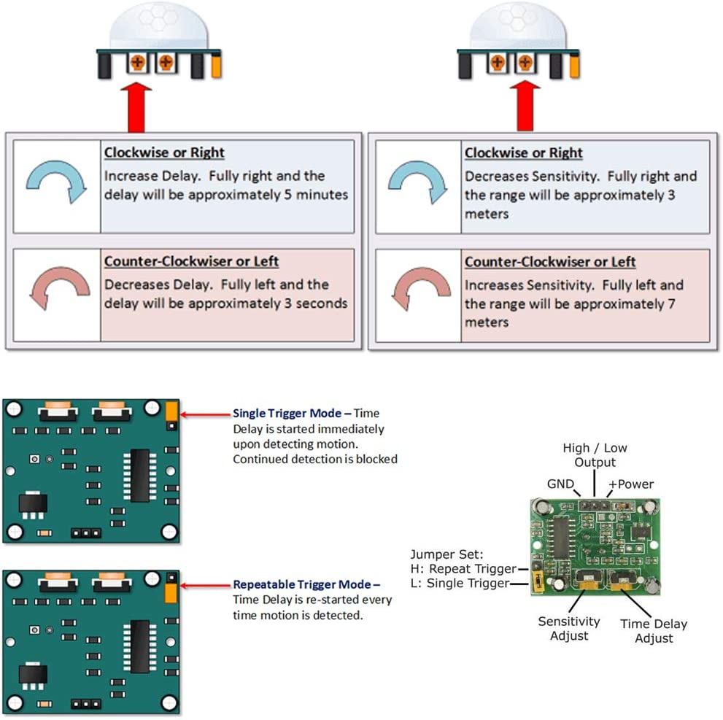

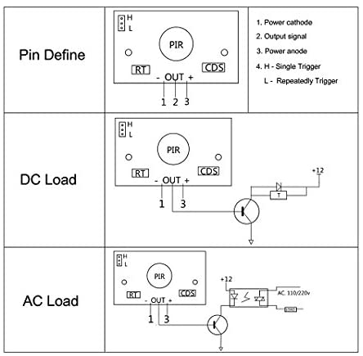

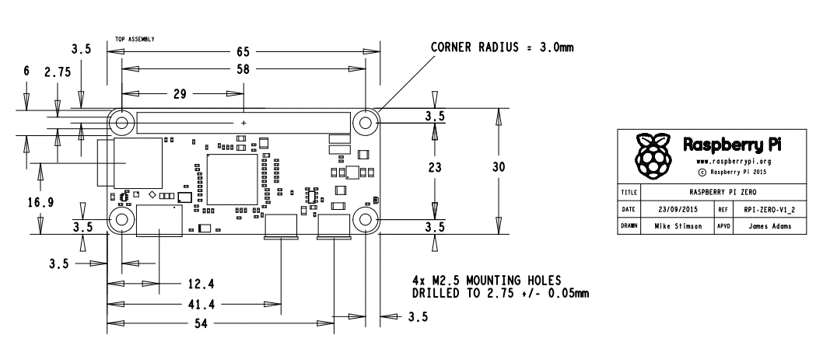

|  |  |  |  |
| --- | --- | --- | --- |
| **Item Name** | **User Visibility** | **Power source** |  |
| Power supply | No | 24vac |  |
| RPI zero | No | 5vdc |  |
| Camera | Yes | Internal |  |
| Audio | No | Internal |  |
| Switch | Yes | GND |  |
| Motion sensor | Yes | 3.3Vdc , GND |  |
| LED | Yes | 3.3vdc/GND |  |

Length: 33(motion sensor) + 25 (camera Module) + 16 (Button) =

Height : Audio board + pi zero == 28mm

Inner 86x41

External 90*45

Motion sensor dia= 23.25 mm holding rest pillar height 7mm from top

Camera lenses dia= 14.02 , holding rest pillar height 9mm from top

Button dia= 13.25mm

Software Installation

1. Paho MQQT client installation
   1. Check whether **Python3** is installed by executing “python3 –version” install the python3 in case it is not installed by command “sudo apt install python3”
   2. Install **paho-mqtt** package for mqtt client by command “sudo pip3 install paho-mqtt” make sure pip3 is installed if not then use command “sudo apt-get install python3-pip” in case pip3 is not installed.
   3. Check the paho-mqtt package installed by command “ pip3 list” it will list all the pip package installed in the device.